The Waterdeep Post

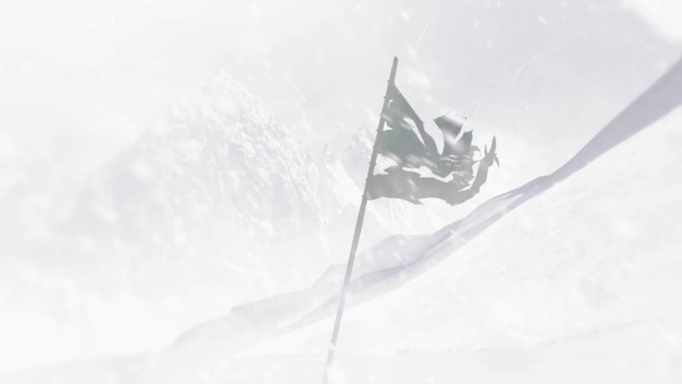

# Northern army massacred

*By Thimble Smallfoot*

On this horrific day, news reaches Neverwinter that a contingency of over 200 soldiers has been defeated in battle in the Spine of the World. The handful of survivors were local guides that had been hired to help lead the army through the treacherous terrain.

The guides are in poor condition and lay in the military hospital in Neverwinter. While the guides and military officials are not speaking publicly about the events, sources inside have confirmed that the army was set out to combat a magical force, emanating cold high up in the mountains. An anonymous source was quoted saying, “intelligence reports from returned scouts speak of a castle of ice guarded by artic creatures that have been seldom, if ever, seen”.

We have reported on the movement of this army since they left Neverwinter but only speculated on its purpose. The assumed goal of the army was to defeat the supernatural source of cold that seems to have made home in the mountains, but no concrete information was able to be gathered about the entity or it’s motives. Until now it was unclear whether this force was malevolent but recent events have, unfortunately, proved that to be the case.

The Lord’s Alliance will likely send out letters to the families of the lost in the coming days, which is just another devastating blow the people of the Sword Coast are dealing with this season.

# Solstice Festivals Canceled DUe to drOught

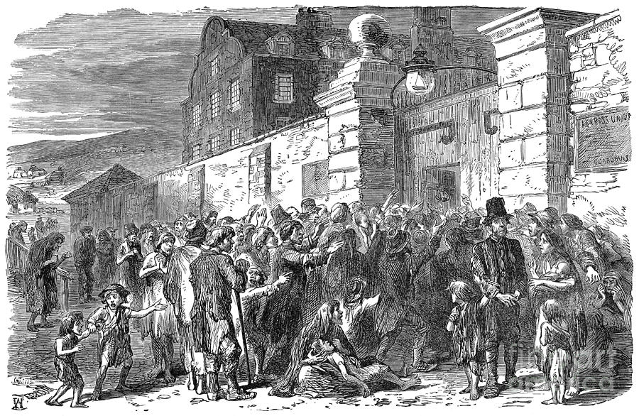

*By Garfield Thornsbury*

The events planned for this year’s Feast of the Sun are being canceled up and down the sword coast. The cities of Waterdeep and Baldur’s Gate have assured the public that their festivities are still going off without a hitch, if a lack of food isn’t considered a hitch. Even the major port cities are having to curtail their celebrating to that of drink and dance as the food shortage continues to take lives.

With Sword Coast rivers and lakes, as far south as the Elturgard region, drying up, farmers are left with no crops and the entire region is left with nothing to eat. The waterways along the Sword Coast rely on water generated by the northern snow melt, and with the northern temperatures continuing to drop, even nearing mid-summer, the drought is showing no signs of stopping.

This seemingly unforeseen circumstance was predicted by the famous gnome professor of Wizardry, Gurlich Squiglock, when he warned the Academy of Sciences and the Lord’s Alliance with his published paper on the recent temperature trends near the Spine of the World. In his paper he is quoted to claim, “the decrease in temperatures and the growth rate of southern artic expansion will lead to a freezing of all ground water. This will exacerbate the typical summer drought conditions and lead to a region wide food shortage.”

Professor Squiglock acknowledges that his paper does little to devise a solution to the issue but he has been working with the Lord’s Alliance since early spring on putting together a plan. So far, Gurlich and the Lord’s Alliance are predictably silent about their plans, which has been a consistent theme of this horrific episode thus far. As reports of riots and loot spread across the region, the Alliance will need to give the people more than just rumors if they plan to keep the peace.

Chult Burglar Strikes Trice

*By Thimble Smallfoot*

A third priceless artifact has gone missing, this time from the Chult Museum of History in Waterdeep. The missing artifact is a jade statue of a beetle, continuing the modus operandi of the previous two heists.

The museum has been on high alert since the remaining artifacts were returned to Waterdeep after the original incident in Baldur’s Gate. Security inside the museum was tripled and a full staff of guards were stationed there after hours.

Similar to the first incident, the Chult relics were placed inside cages with state-of-the-art locks. When questioned about the type of locks used, the museum refused to comment, but a source familiar with the security of the exhibit claims that they are the same type of locks used at the Baldur’s Gate museum.

With the artifacts being so similar, many scholars have started to take notice of these events. When reaching out to one such scholar, Professor Greta Yarvitz, she claimed that, “the statues all had a similar symbol on the bottom and seemed to be part of a set.” Upon examination of the rubbings, taken off the objects when they were first discovered, Greta and her colleagues have determined that they have the same maker, and must all be from the same time and location. This only furthers speculation that the artifacts are from the Hidden Shrine of Tamoachan.

Officials are baffled and seem to be left with their only option is to throw money at the situation. Both museums, their respective cities, and the Lady Halriel have issued a combined reward of 1500 gold leading to the return of the three artifacts.

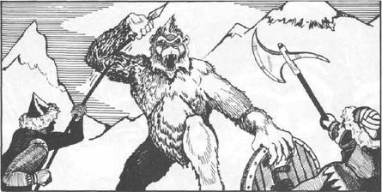

Refugees Attacked by Yetis

*By Torefoot Isildur*

As if news couldn’t get any worse for the northern refugees, reports are coming in from Longsaddle that a family of refugees has been attacked north of town, leaving only a young, teenage boy as the lone survivor.

The family, like so many others, was migrating from Mirabar as their food and fuel ran out. This event brings another painful realization that the problems of the north are spreading further south than any of the experts expected possible. Even the northern city of Luskan is producing whisperings of an exodus as they are continually in need of shipments of supplies.

The self-sustaining economies of the north have fallen into nothing more than a congregation of beggars, and who could blame them. Anywhere north of Longsaddle, is seeing all but the tallest trees disappeared by snow, leaving the prospect of hunting or gathering to the birds. With summer supposed to be in full swing and towns such as Luskan and Longsaddle under siege by arctic beasts, many of us are left looking upwards towards the only source of succor we have left.